# SPRINT -1 DOCUMENTATION

|  |  |
| --- | --- |
| Date | 29 OCTOBER 2022 |
| Team ID | PNT2022TMID42792 |
| Project Name | Project-Smart Solution for Railways |

**DESCRIPTION :**

In this sprint, we have designed a webpage for the passenger to book the train ticket easily. Login page is designed for the user to login and after successful login they are redirected to the ticket booking form.

In this form users are asked to fill the personal details, boarding , destination details and seats . If the user enters the appropriate details then the QR code is generated. User can take the photo of this QR code displayed and store it for ticket verification during the journey.

# FEATURES :

* Login Page
* Sign Up
* About
* Ticket booking Form
* QR code generation

# HOME PAGE :

LOGIN PAGE

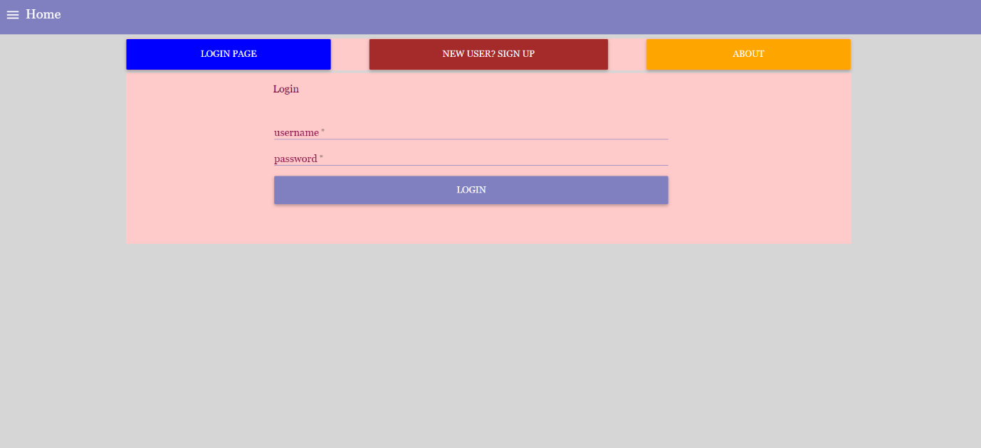

SIGN UP PAGE

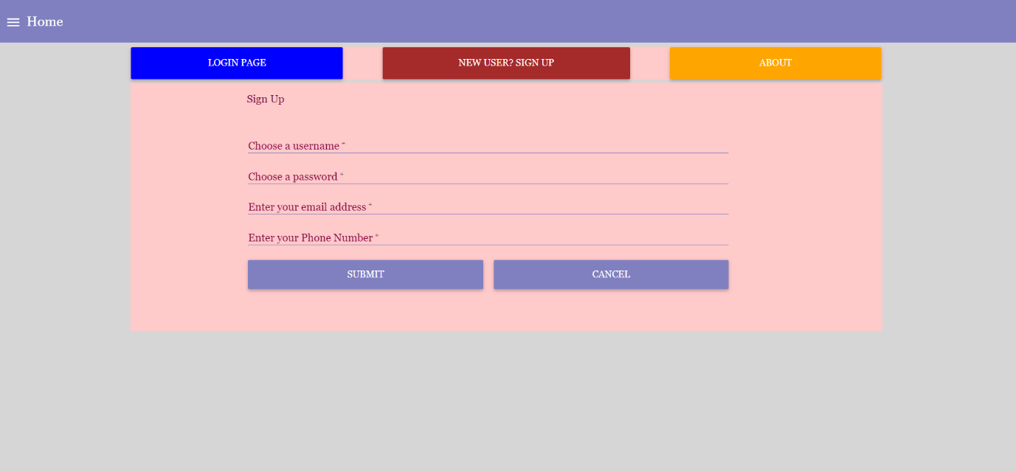;

ABOUT

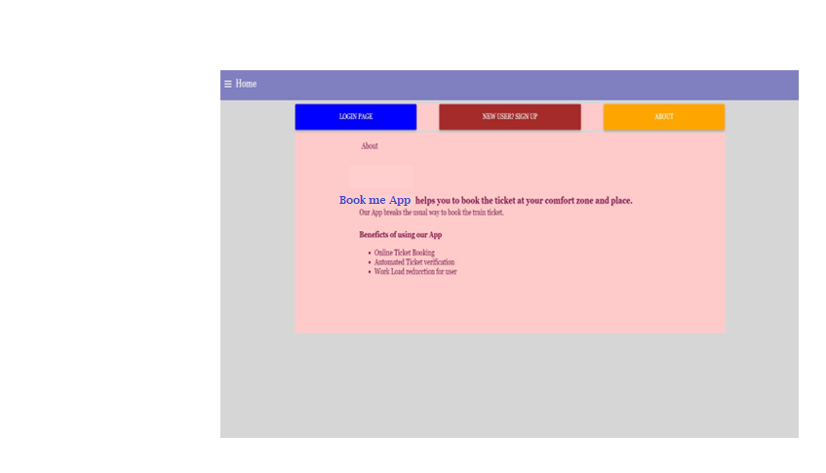

# NODE RED FLOW :

Home page flow

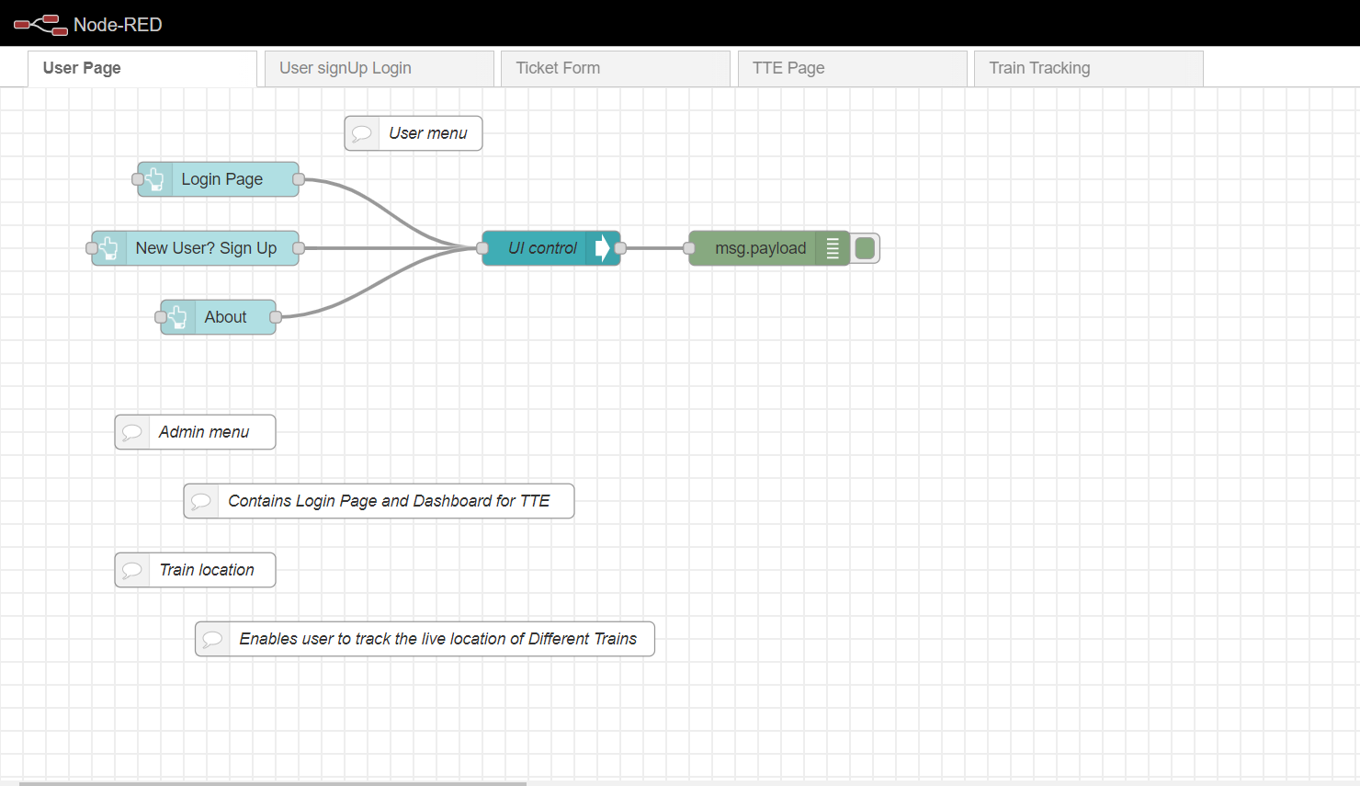

Login page flow

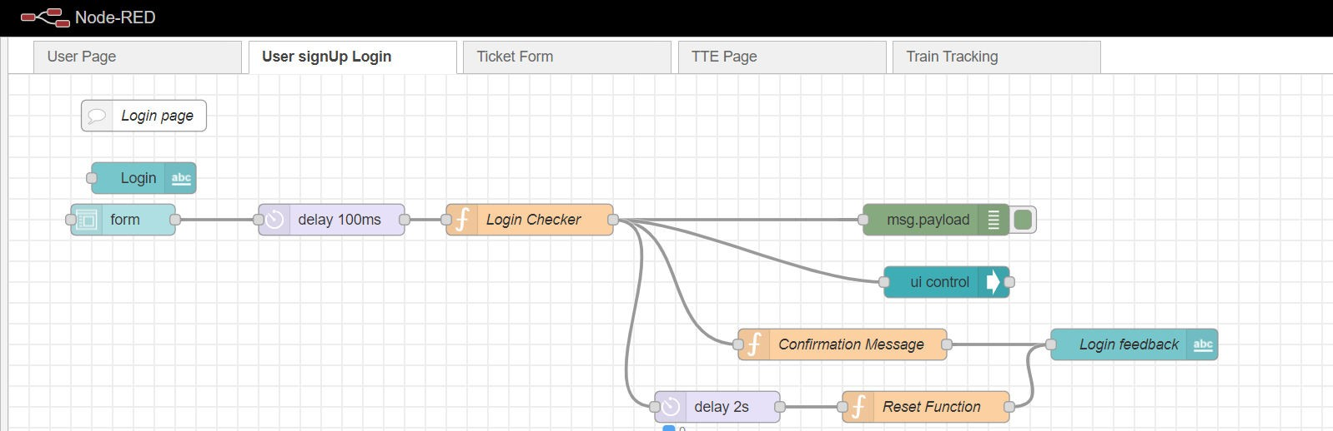

Sign up flow

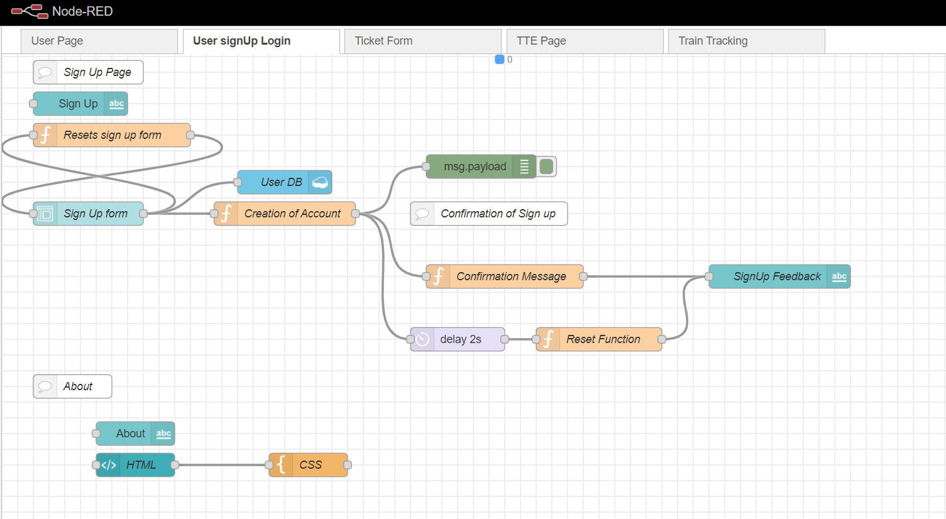

# TICKET BOOKING FORM :

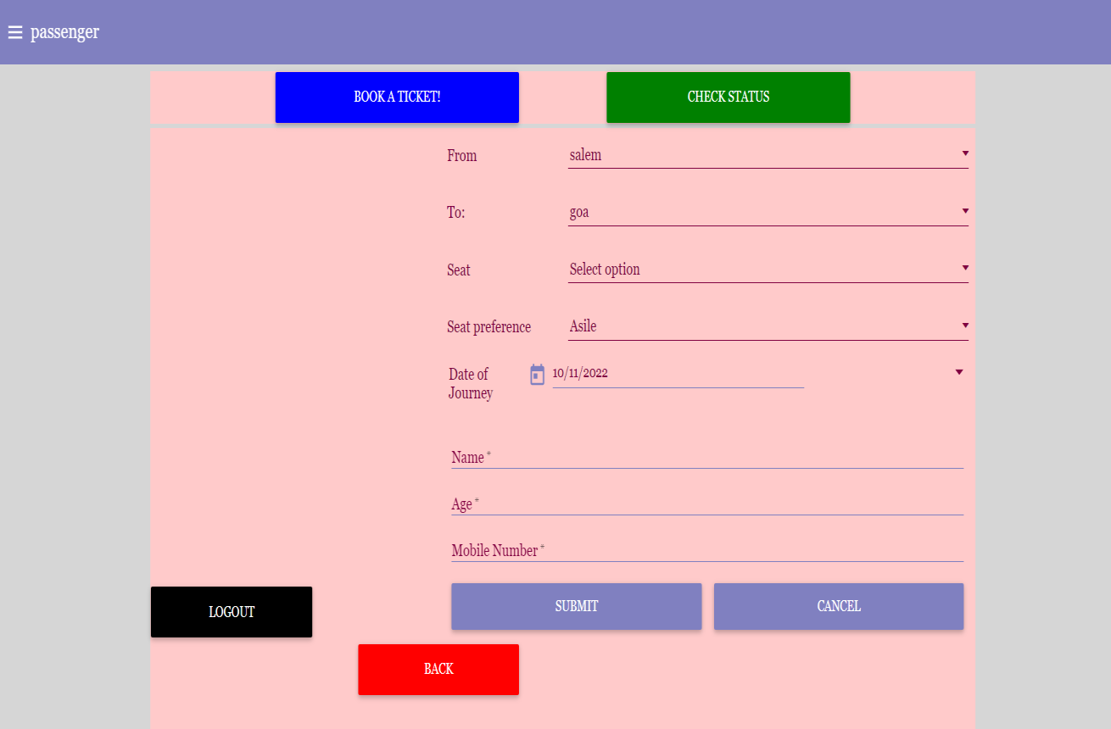

**TICKET BOOKING FORM FLOW :**

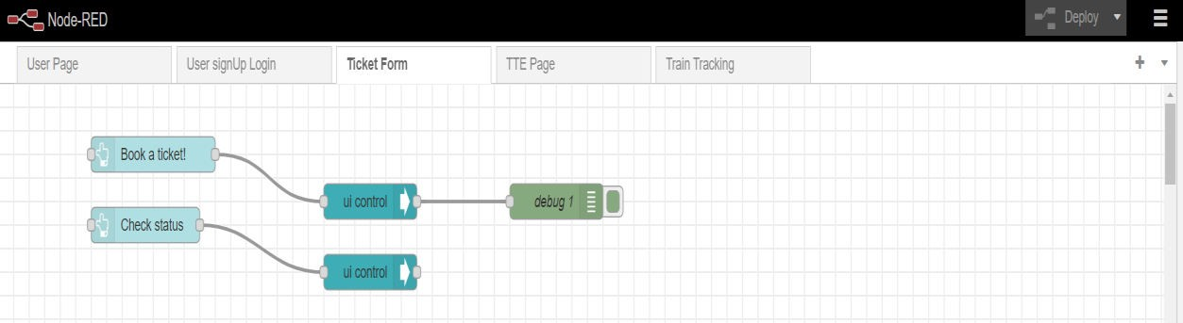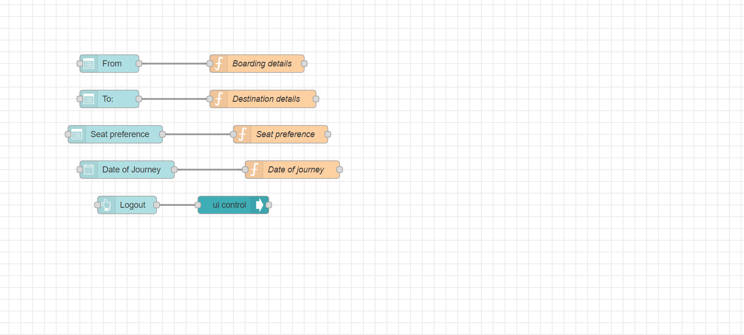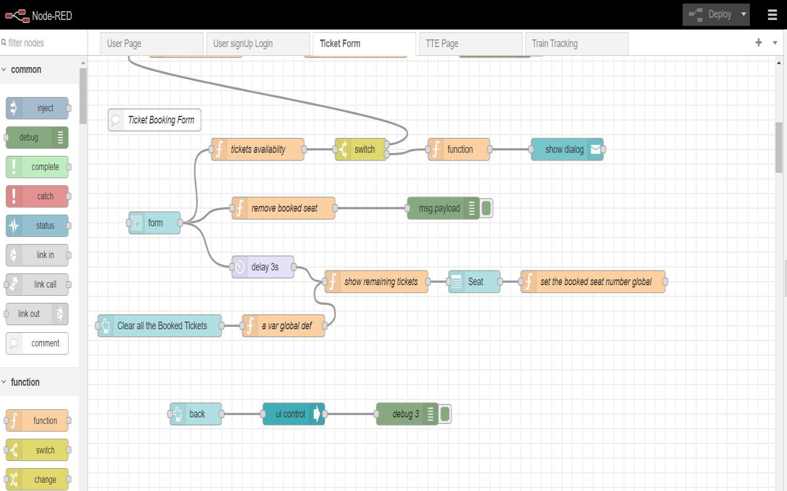

# QR CODE GENERATION :

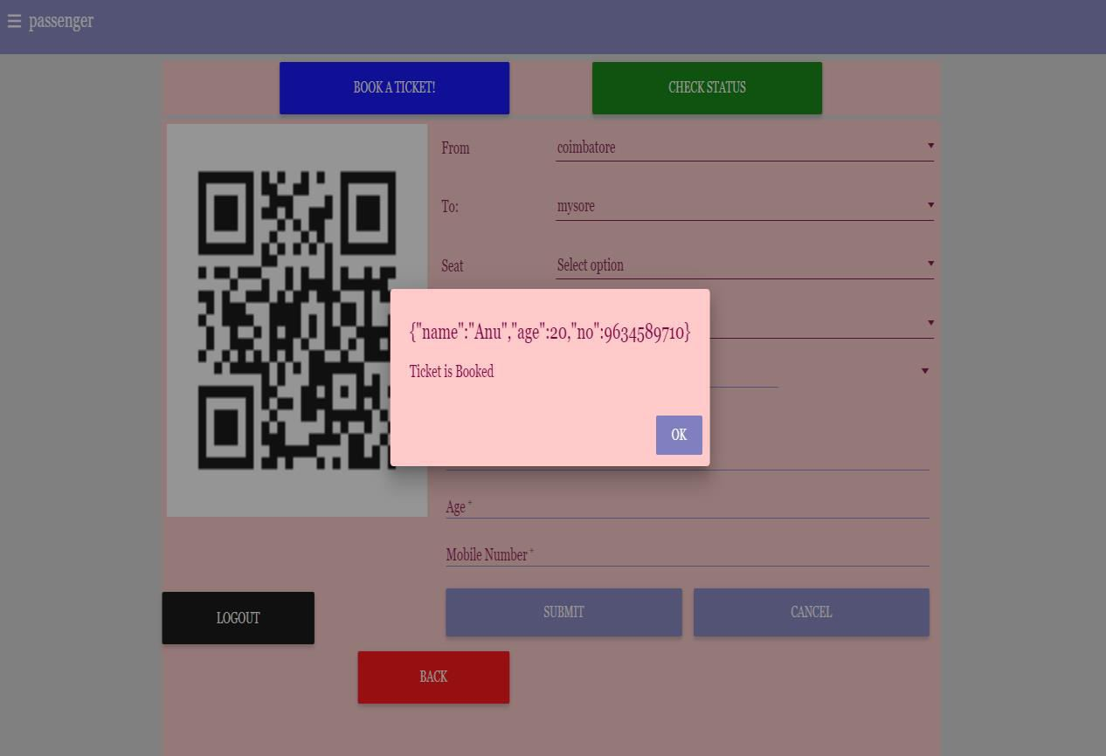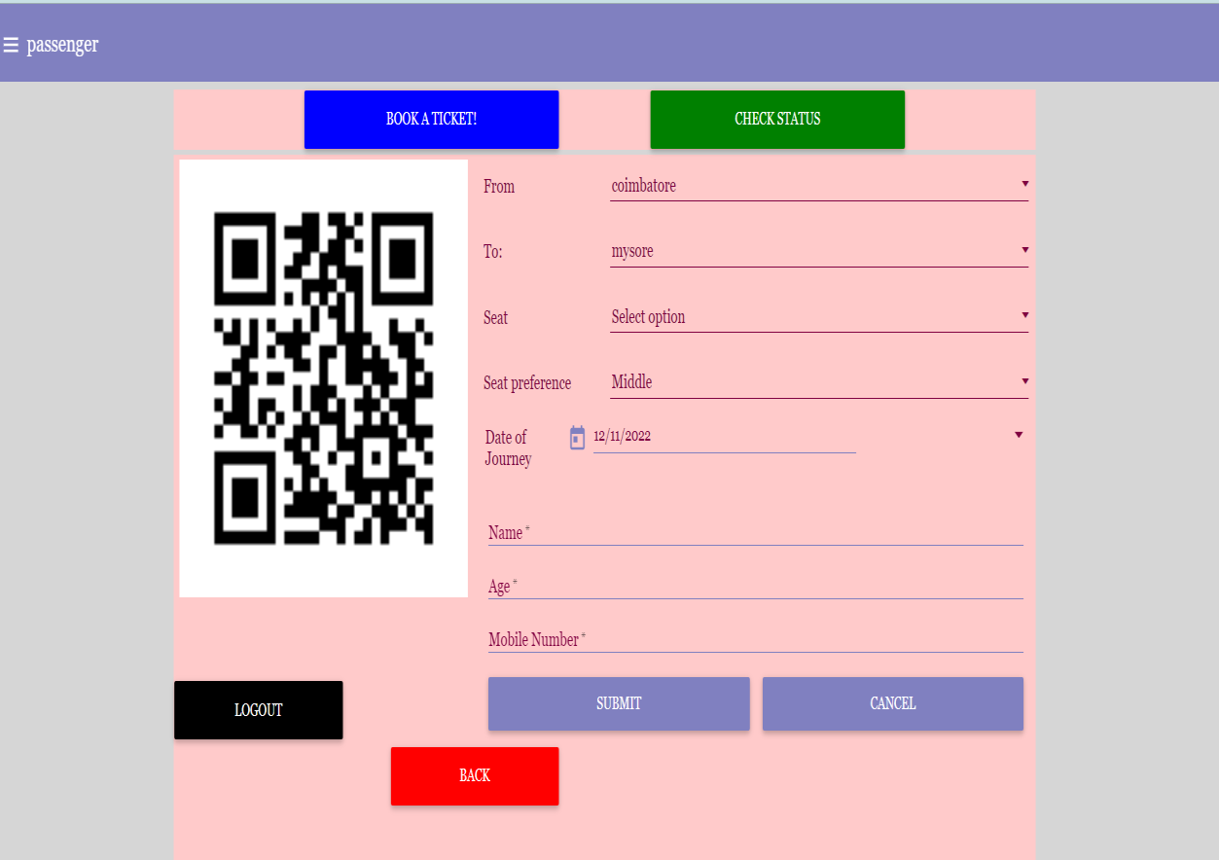

**QR CODE GENERATION FLOW:**

